4 Proposed System

Proposed System Explanation

Our proposed system has two componenets – one is topic modelling and the other is article recommendation. The first component of our project will have a text preprocessing part which will prepare our articles for the modelling phase. With the preprocessed docs we can start out modelling phase. We have chosen 2 hybrid models (TF-IDF with LDA and NMF) to see which performs the best in our scenario. Next we will have a comparison to find out which model performs the best. Our system will use the hybrid model which has the best score in statistical measure like coherence. During the modelling process our system will choose the best number of topics that should be set as a parameter to get the highest coherence score possible to be achhieved for the model. Our system will give us the topics it modelled from our preprocessed docs along with the words that are important under that topic along with their weights. Finally we can input all our documents to get a topic number assigned to each model. Similarly we can give articles as user input and our model can return as topic that it assigned to the given article/document. The second component of our project is an article recommendation system that can compare documents in our corpus and compare them with a given article or word to find the most similar articles to the given input. This will use the tf-idf scores of tokens in all the articles and generate the term-term correlation matrix. Finally using this our system will rank the documents in the corpus and give the 10 most relevant documents to the given input.

Flow Diagram explanation

topic modelling

On our dataset we first perform analysis and then preprocess the documents in the dataset. Then we go into the modelling phase with two hybrid models and we compare between them using statistical measures. We obtain the final model to which we give a document as input which is preprocessed and provided to the model which assigns a topic to the document and gives it as output.

Article recommendation

Given a document, we first find the correlation between all the documents and the document provided using cosine similarity and then the documents are ranked and the most relevant documents are given as output.

Architecture diagram explanation

topic modelling

Given our dataset, firstly we analyse the text length, title length, the mean of the text length. Next in the preprocessing phase we perform the following steps, converting to lower case, removing special characters and punctuations, removing stop words, tokenisation, lemmatisation, etc. We store the preprocessed documents in a file as it can be a cumbersome process to preprocess the text every time. Next we create a dictionary of our preprocessed token which we will feed to our hybrid models. We train 2 hybrid models, TF-IDF with LDA and TF-IDF with NMF. We feed our dictionary to the TF-IDF model to the get scores of each token in the document. Doing this the NMF and LDA model will have better understanding of each term in a given document. For each model we will check the coherence scores for different number of topics assigned and then choose the best number of topics to be set as parameter for each model. We compare the coherence scores of NMF and LDA models which will help us decide on which hybrid model is the best. To this model we can give documents as input and as an output it will give the topic assigned to it by the model. As as extension to our project, we can create a webapp, which will take the document as input from the user and give the topic it belongs to as output.

Article Recommendation:

A user gives a text as input, and the documents of our corpus are fed to theTF-IDF vectoriser to get the TF-IDF scores. Using this matrix we calculate the term-term correlation matrix. Every term of this matrix gives the correlation between two terms, or how strongly a term can occur in a document to the occurance of another term in it. The documents are ranked in the next step according to their similarity values and our system will return the top 10 documents in the corpus that it thinks are relevant to the given input.

Psuedocode

topic modelling

load dataset
for every document in dataset do:
- removing punctations
- convert to lower case
- removing special characters
- removing stop words
- lemmatisation
- stemming

store the preprocessed docs
dictionary=dictionary(processed docs)
corpus=dictionary_with_count_of_occurance(processed docs)

tfidf=tfidfmodel(corpus)
tfidfcorpus=tfidf[corpus]

for i from 10 to 100 in increment of 5:
testmodel=ldamodel(topic number=i)
testmodelscore=coherencemodel(testmodel, docs, dictionary, coherence=”c_v”)
coherencelda=testmodelscore.get_coherence()
store the coherencelda values

plot_all_coherence_scores
choose topic number corresponding to maximum coherence score

lda_model_tf_idf=ldamodel(number of topics=topics that give highest coherence, corpus_tf_idf, dictionary)

print(topics)

visualise the topics using pyLDAvis
coherence_model_lda=coherencemodel(lda_model_tf_idf, docs, dictionary, coherence=”c_v”)
coherence_lda=coherence_model_lda.get_coherence()
print(coherence_lda)

we repeat the same procedure for nmf model to choose the ideal number of topics that gives the highest LDA score.

tfidf2 = tfidf_vectorizer.fit_transform(docs)
nmf=NMF(n_components=best_no_of_topics).fit(tfidf2)
topic_df=dataframe with words of topics and the entire topic
docweights = nmf.transform(tfidf_vectorizer.transform(docs))
print("Coherence Score", cm.get_coherence())
docid = df['docid'].tolist()

df_temp = pd.DataFrame({
'docid': docid,
'topic_num': docweights.argmax(axis=1)
})

# Merging to get the topic num with url
merged_topic = df_temp.merge(
topic_df,
on='topic_num',
how='left'
)

# Merging with the original df
df_topics = pd.merge(
df,
merged_topic,
on='docid',
how='left'
)

compare the best models on the coherence score

topic=bestmodel(userinput)

print(topic)

article recommendation

userinput=input text from user
docs=copus docs
x=[]
for doc in docs:
tf_idf_scores=Tfidfvectorizer().fit_transform([userinput, doc])
x.append(((tfidf_score * tfidf_score.T).A)[0, 1])
print(sorted(x)[:10])

In topic modelling, we get the documents, proprocess them first. Then we create dictionary and pass it to our tfidf model to get the scores. Then we use this new corpus and find the best number of topics for our lda model. Then we create our lda model with the best number of topics. In the process we find the number words that form the topic, visualise it using pyLDAvis. In NMF we follow the same prcedure of finding the number of topics. We set our parameter for nmf model accordingly.we find the words that form a topic and assign topics for every document in the corpus. We find the coherence score and find out which model performs the best. For the article recommendation part we can first pass the user input and calculate the term term correlation matrix between every document and the term. The we rank the documents to display the top 10 documents similar to the user input.

Experiment and Results

Dataset

For more acurate topic modelling we need to choose a dataset that has articles of decent size to cover a large number of topics. In our project we have chosen such a dataset which consists of articles from almost any field. The dataset consists of articles from different medium, towardsdatascience, etc. It consists of the authors, link, title, and the text of the article.

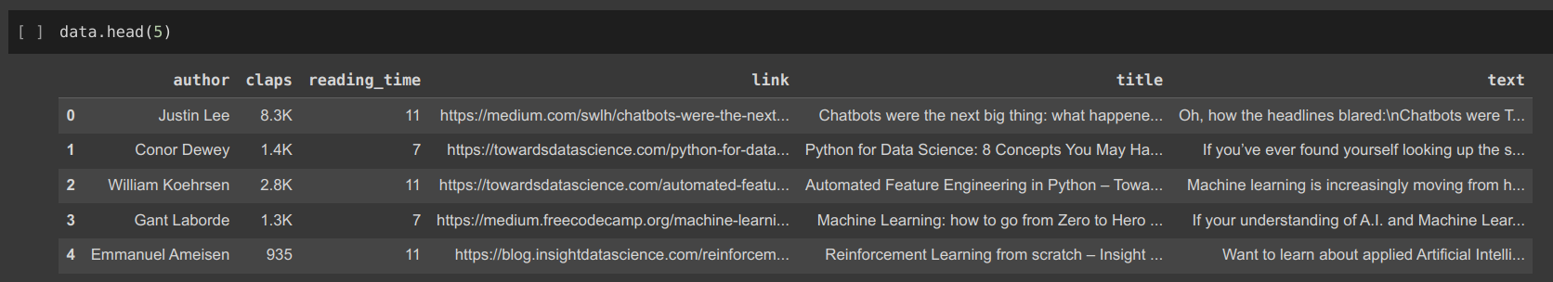
There are 337 articles in our dataset

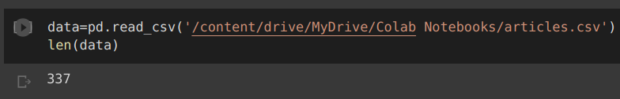
The average length of articles in the dataset is around 11120 words

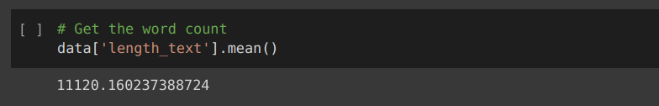

The following are the distribution of title length given as histogram

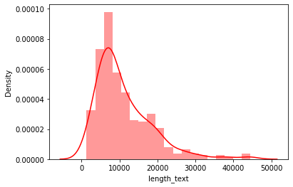

Distribution of length of titles of articles.

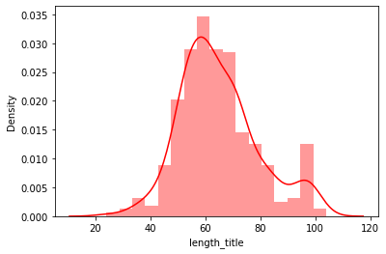

A box plot to to visualise the length of articles have been plot

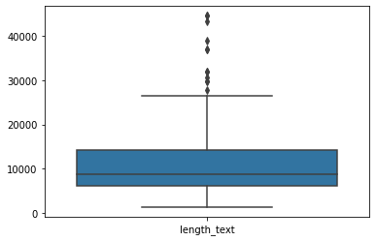

Text Processing on the articles

Code:

stemmer = SnowballStemmer('english')

def lemmatize_stemming(text):
return stemmer.stem(WordNetLemmatizer().lemmatize(text, pos='v'))

def preprocess(text):
result = []
for token in gensim.utils.simple_preprocess(text):
regex = re.compile('[' + re.escape(string.punctuation) + '0-9\\r\\t\\n]')
text = regex.sub(" ", text.lower())
words = text.split(" ")
words = [re.sub('\S*@\S*\s?', '', sent) for sent in words]
words = [re.sub('\s+', ' ', sent) for sent in words]
words = [re.sub("\'", "", sent) for sent in words]
if token not in stop_words and len(token) > 3:
result.append(lemmatize_stemming(token))
return result

- First we remove the punctuation marks from the articles.
- Next we convert entire articles to lower case. We then split on spaces to convert them to tokens.
- Remove whitespaces, quotes, apostrophes.
- Remove stop words and any token that has a length lesser than equal to 3.
- We append all the processed tokens in a list and store it document id wise in a new dataset which we will load every time on the program’s execution.

After preprocessing we have a dataset of a list of tokens in every document:

